**Device list – dl**

The script, */home/dzunic/XIV/MyScripts/device_list.ksh*, lists all devices, IPs and for XIV, switches and FS serial numbers, for the chosen site in a second.

Yes, it displays only names, IPs and some serial numbers. But most of the time we need only that. In case we need more information about devices and sites we could open the inventory documents.

I use the alias “dl” for it that is defined in the environment file */home/dzunic/.bashrc*:

alias dl="/home/dzunic/SCE+/XIV/MyScripts/device_list.ksh"

This script does not check if the tunnel is correct because you might have need to see devices for different sites than the one you are working on at the moment.

Data about devices is stored in the flat inventory files:

XIV - in the folder */home/dzunic/XIV/XIVscripts/host_lists/xiv_inv.txt*

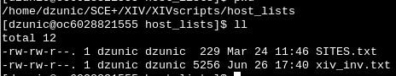

SVC - */home/dzunic/SCE+/SVC/Scripts/svc_inv.txt*

V7000 - */home/dzunic/SCE+/V7000/Scripts/v7k_inv.txt*

Switches - */home/dzunic/SCE+/SAN/Scripts/switch_inv.txt*

FS - */home/dzunic/SCE+/FlashSystem/Scripts/fs_inv.txt*

The file SITES.txt lists all sites and it is used by scripts for all devices.

At the beginning of all scripts there is an adjustment part where you need to do adjustment for file and folders locations on your workstation.

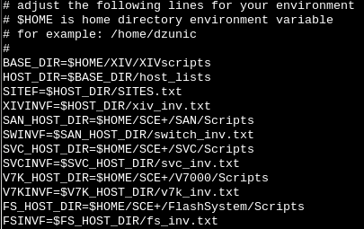

This script is very useful and fast when you need to get a short list of devices for one site.

Just type “dl”:

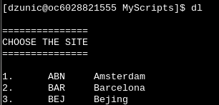

and then choose the site:

